1 run......

Downloading: 100%

411/411 [00:00<00:00, 11.8kB/s]

Downloading: 100%

263M/263M [00:10<00:00, 26.0MB/s]

training 1 epoch...

73.01426815986633 seconds used......

1 training finished! average train loss: 0.9988318365954217

evaluating...

Confusion matrix, without normalization

[[109 12 3]

[ 66 95 3]

[763 63 39]]

Normalized confusion matrix

[[0.87903226 0.09677419 0.02419355]

[0.40243902 0.57926829 0.01829268]

[0.88208092 0.07283237 0.04508671]]

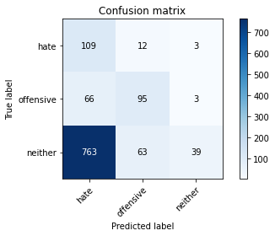

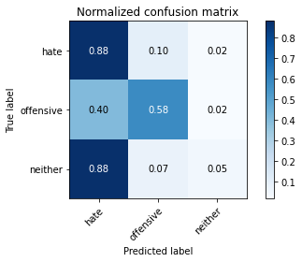

precision recall f1-score support

hate 0.12 0.88 0.21 124

offensive 0.56 0.58 0.57 164

neither 0.87 0.05 0.09 865

accuracy 0.21 1153

macro avg 0.51 0.50 0.29 1153

weighted avg 0.74 0.21 0.17 1153

average eval_loss: 1.0959773618599464, accuracy: 0.21075455333911536

training 2 epoch...

72.00703597068787 seconds used......

2 training finished! average train loss: 0.8436940841021991

evaluating...

Confusion matrix, without normalization

[[102 20 2]

[ 54 105 5]

[663 52 150]]

Normalized confusion matrix

[[0.82258065 0.16129032 0.01612903]

[0.32926829 0.6402439 0.0304878 ]

[0.76647399 0.06011561 0.1734104 ]]

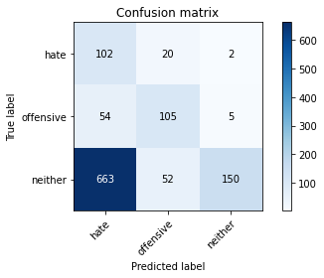

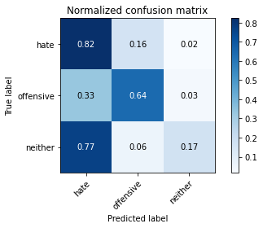

precision recall f1-score support

hate 0.12 0.82 0.22 124

offensive 0.59 0.64 0.62 164

neither 0.96 0.17 0.29 865

accuracy 0.31 1153

macro avg 0.56 0.55 0.38 1153

weighted avg 0.81 0.31 0.33 1153

average eval_loss: 1.028853935414347, accuracy: 0.3096270598438855

training 3 epoch...

71.99252581596375 seconds used......

3 training finished! average train loss: 0.6819223085684436

evaluating...

Confusion matrix, without normalization

[[ 80 32 12]

[ 24 125 15]

[386 90 389]]

Normalized confusion matrix

[[0.64516129 0.25806452 0.09677419]

[0.14634146 0.76219512 0.09146341]

[0.44624277 0.10404624 0.44971098]]

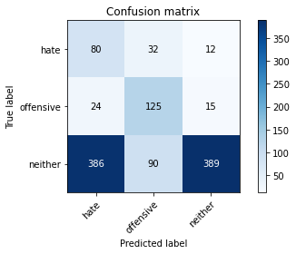

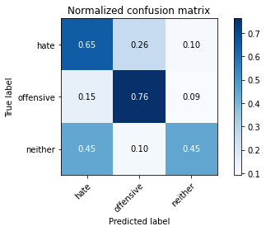

precision recall f1-score support

hate 0.16 0.65 0.26 124

offensive 0.51 0.76 0.61 164

neither 0.94 0.45 0.61 865

accuracy 0.52 1153

macro avg 0.53 0.62 0.49 1153

weighted avg 0.79 0.52 0.57 1153

average eval_loss: 0.9729532979685684, accuracy: 0.5151777970511708

training 4 epoch...

71.91441488265991 seconds used......

4 training finished! average train loss: 0.44467651356189025

evaluating...

Confusion matrix, without normalization

[[ 89 16 19]

[ 36 104 24]

[352 41 472]]

Normalized confusion matrix

[[0.71774194 0.12903226 0.15322581]

[0.2195122 0.63414634 0.14634146]

[0.40693642 0.04739884 0.54566474]]

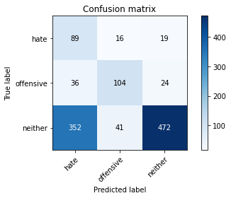

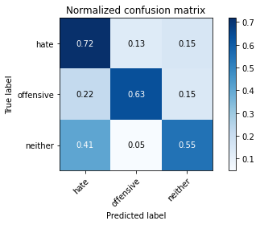

precision recall f1-score support

hate 0.19 0.72 0.30 124

offensive 0.65 0.63 0.64 164

neither 0.92 0.55 0.68 865

accuracy 0.58 1153

macro avg 0.58 0.63 0.54 1153

weighted avg 0.80 0.58 0.64 1153

average eval_loss: 1.0180484796392506, accuracy: 0.5767562879444926

training 5 epoch...

71.97930908203125 seconds used......

5 training finished! average train loss: 0.21681028351719892

evaluating...

Confusion matrix, without normalization

[[ 66 16 42]

[ 29 108 27]

[234 65 566]]

Normalized confusion matrix

[[0.53225806 0.12903226 0.33870968]

[0.17682927 0.65853659 0.16463415]

[0.27052023 0.07514451 0.65433526]]

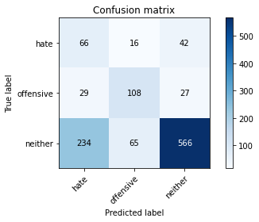

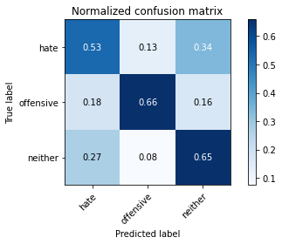

precision recall f1-score support

hate 0.20 0.53 0.29 124

offensive 0.57 0.66 0.61 164

neither 0.89 0.65 0.75 865

accuracy 0.64 1153

macro avg 0.55 0.62 0.55 1153

weighted avg 0.77 0.64 0.68 1153

average eval_loss: 1.1399997668019657, accuracy: 0.6418039895923677

training 6 epoch...

71.95182347297668 seconds used......

6 training finished! average train loss: 0.10648474005782711

evaluating...

Confusion matrix, without normalization

[[ 77 19 28]

[ 34 107 23]

[349 63 453]]

Normalized confusion matrix

[[0.62096774 0.15322581 0.22580645]

[0.20731707 0.65243902 0.1402439 ]

[0.40346821 0.07283237 0.52369942]]

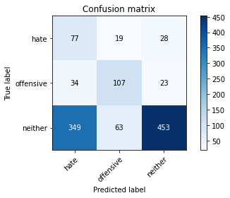

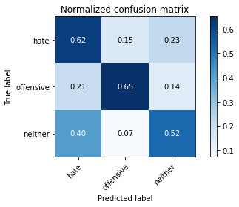

precision recall f1-score support

hate 0.17 0.62 0.26 124

offensive 0.57 0.65 0.61 164

neither 0.90 0.52 0.66 865

accuracy 0.55 1153

macro avg 0.54 0.60 0.51 1153

weighted avg 0.77 0.55 0.61 1153

average eval_loss: 1.620063720078304, accuracy: 0.5524718126626192

training 7 epoch...

72.02288174629211 seconds used......

7 training finished! average train loss: 0.07067346791570474

evaluating...

Confusion matrix, without normalization

[[ 92 17 15]

[ 38 115 11]

[418 81 366]]

Normalized confusion matrix

[[0.74193548 0.13709677 0.12096774]

[0.23170732 0.70121951 0.06707317]

[0.48323699 0.09364162 0.42312139]]

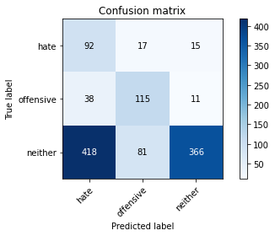

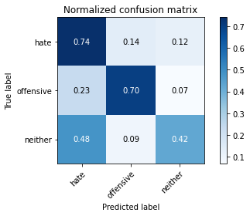

precision recall f1-score support

hate 0.17 0.74 0.27 124

offensive 0.54 0.70 0.61 164

neither 0.93 0.42 0.58 865

accuracy 0.50 1153

macro avg 0.55 0.62 0.49 1153

weighted avg 0.80 0.50 0.55 1153

average eval_loss: 2.2880616188049316, accuracy: 0.49696444058976585

training 8 epoch...

71.9519407749176 seconds used......

8 training finished! average train loss: 0.05554101677816583

evaluating...

Confusion matrix, without normalization

[[ 82 14 28]

[ 37 105 22]

[337 61 467]]

Normalized confusion matrix

[[0.66129032 0.11290323 0.22580645]

[0.22560976 0.6402439 0.13414634]

[0.38959538 0.07052023 0.53988439]]

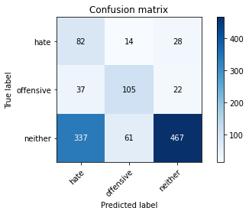

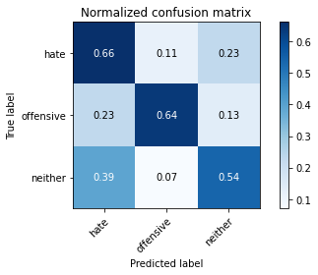

precision recall f1-score support

hate 0.18 0.66 0.28 124

offensive 0.58 0.64 0.61 164

neither 0.90 0.54 0.68 865

accuracy 0.57 1153

macro avg 0.56 0.61 0.52 1153

weighted avg 0.78 0.57 0.62 1153

average eval_loss: 1.941960252564529, accuracy: 0.5672159583694709

training 9 epoch...

71.93757224082947 seconds used......

9 training finished! average train loss: 0.04175359529506836

evaluating...

Confusion matrix, without normalization

[[102 16 6]

[ 53 103 8]

[579 58 228]]

Normalized confusion matrix

[[0.82258065 0.12903226 0.0483871 ]

[0.32317073 0.62804878 0.04878049]

[0.66936416 0.06705202 0.26358382]]

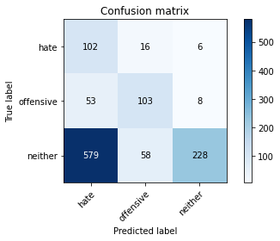

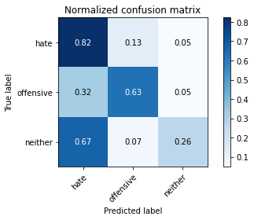

precision recall f1-score support

hate 0.14 0.82 0.24 124

offensive 0.58 0.63 0.60 164

neither 0.94 0.26 0.41 865

accuracy 0.38 1153

macro avg 0.55 0.57 0.42 1153

weighted avg 0.80 0.38 0.42 1153

average eval_loss: 3.4843793614157317, accuracy: 0.375542064180399

training 10 epoch...

71.85087966918945 seconds used......

10 training finished! average train loss: 0.0389186125096222

evaluating...

Confusion matrix, without normalization

[[ 87 18 19]

[ 40 104 20]

[361 71 433]]

Normalized confusion matrix

[[0.7016129 0.14516129 0.15322581]

[0.24390244 0.63414634 0.12195122]

[0.41734104 0.08208092 0.50057803]]

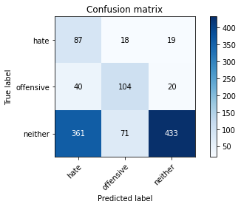

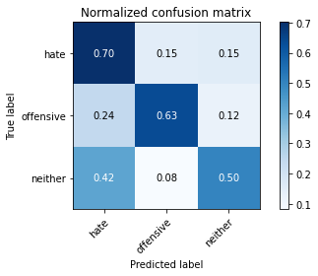

precision recall f1-score support

hate 0.18 0.70 0.28 124

offensive 0.54 0.63 0.58 164

neither 0.92 0.50 0.65 865

accuracy 0.54 1153

macro avg 0.54 0.61 0.50 1153

weighted avg 0.78 0.54 0.60 1153

average eval_loss: 2.1804700226619325, accuracy: 0.5411968777103209

2 run......

training 1 epoch...

72.02540349960327 seconds used......

1 training finished! average train loss: 0.9913517318311191

evaluating...

Confusion matrix, without normalization

[[102 17 5]

[ 61 96 7]

[597 49 219]]

Normalized confusion matrix

[[0.82258065 0.13709677 0.04032258]

[0.37195122 0.58536585 0.04268293]

[0.69017341 0.0566474 0.25317919]]

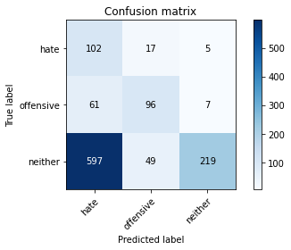

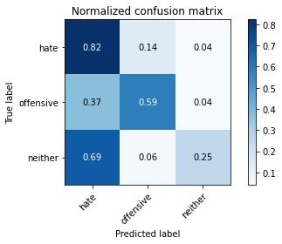

precision recall f1-score support

hate 0.13 0.82 0.23 124

offensive 0.59 0.59 0.59 164

neither 0.95 0.25 0.40 865

accuracy 0.36 1153

macro avg 0.56 0.55 0.41 1153

weighted avg 0.81 0.36 0.41 1153

average eval_loss: 0.9320274036506127, accuracy: 0.3616652211621856

training 2 epoch...

72.1032087802887 seconds used......

2 training finished! average train loss: 0.8420883732892218

evaluating...

Confusion matrix, without normalization

[[100 17 7]

[ 51 102 11]

[560 49 256]]

Normalized confusion matrix

[[0.80645161 0.13709677 0.05645161]

[0.31097561 0.62195122 0.06707317]

[0.64739884 0.0566474 0.29595376]]

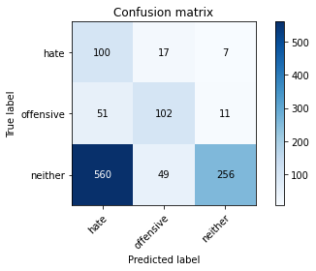

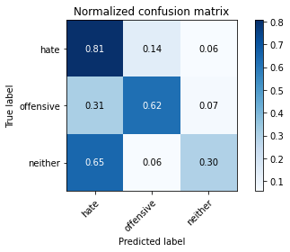

precision recall f1-score support

hate 0.14 0.81 0.24 124

offensive 0.61 0.62 0.61 164

neither 0.93 0.30 0.45 865

accuracy 0.40 1153

macro avg 0.56 0.57 0.43 1153

weighted avg 0.80 0.40 0.45 1153

average eval_loss: 0.9259002321753008, accuracy: 0.39722463139635733

training 3 epoch...

72.07674789428711 seconds used......

3 training finished! average train loss: 0.693067536999782

evaluating...

Confusion matrix, without normalization

[[ 97 17 10]

[ 53 100 11]

[507 62 296]]

Normalized confusion matrix

[[0.78225806 0.13709677 0.08064516]

[0.32317073 0.6097561 0.06707317]

[0.58612717 0.0716763 0.34219653]]

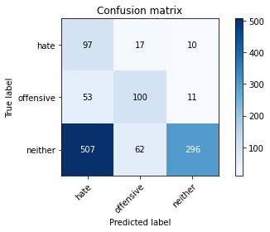

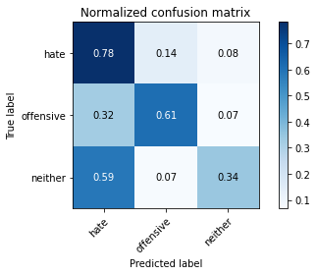

precision recall f1-score support

hate 0.15 0.78 0.25 124

offensive 0.56 0.61 0.58 164

neither 0.93 0.34 0.50 865

accuracy 0.43 1153

macro avg 0.55 0.58 0.44 1153

weighted avg 0.80 0.43 0.49 1153

average eval_loss: 1.0345590135146832, accuracy: 0.42758022549869906

training 4 epoch...

72.16187906265259 seconds used......

4 training finished! average train loss: 0.4394400032858054

evaluating...

Confusion matrix, without normalization

[[ 84 19 21]

[ 42 105 17]

[312 55 498]]

Normalized confusion matrix

[[0.67741935 0.15322581 0.16935484]

[0.25609756 0.6402439 0.10365854]

[0.36069364 0.06358382 0.57572254]]

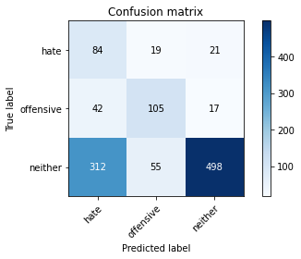

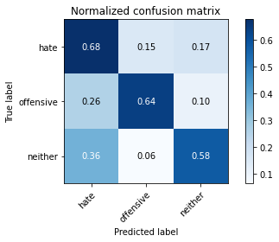

precision recall f1-score support

hate 0.19 0.68 0.30 124

offensive 0.59 0.64 0.61 164

neither 0.93 0.58 0.71 865

accuracy 0.60 1153

macro avg 0.57 0.63 0.54 1153

weighted avg 0.80 0.60 0.65 1153

average eval_loss: 0.9811457950493385, accuracy: 0.5958369470945359

training 5 epoch...

72.01490378379822 seconds used......

5 training finished! average train loss: 0.20676313362838256

evaluating...

Confusion matrix, without normalization

[[ 83 21 20]

[ 44 103 17]

[376 64 425]]

Normalized confusion matrix

[[0.66935484 0.16935484 0.16129032]

[0.26829268 0.62804878 0.10365854]

[0.43468208 0.07398844 0.49132948]]

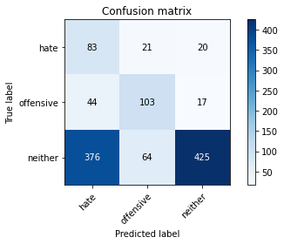

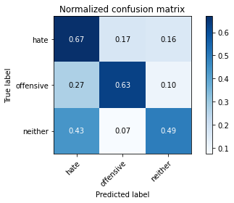

precision recall f1-score support

hate 0.17 0.67 0.26 124

offensive 0.55 0.63 0.59 164

neither 0.92 0.49 0.64 865

accuracy 0.53 1153

macro avg 0.54 0.60 0.50 1153

weighted avg 0.79 0.53 0.59 1153

average eval_loss: 1.4517081472380409, accuracy: 0.5299219427580225

training 6 epoch...

72.03092813491821 seconds used......

6 training finished! average train loss: 0.0986741507215248

evaluating...

Confusion matrix, without normalization

[[ 80 19 25]

[ 45 103 16]

[358 66 441]]

Normalized confusion matrix

[[0.64516129 0.15322581 0.2016129 ]

[0.27439024 0.62804878 0.09756098]

[0.41387283 0.07630058 0.50982659]]

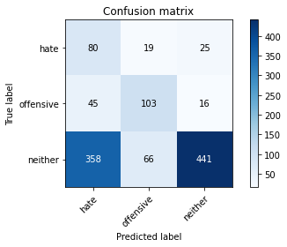

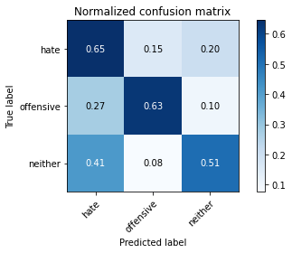

precision recall f1-score support

hate 0.17 0.65 0.26 124

offensive 0.55 0.63 0.59 164

neither 0.91 0.51 0.65 865

accuracy 0.54 1153

macro avg 0.54 0.59 0.50 1153

weighted avg 0.78 0.54 0.60 1153

average eval_loss: 1.6693990251113628, accuracy: 0.5411968777103209

training 7 epoch...

72.0368070602417 seconds used......

7 training finished! average train loss: 0.06991094820910976

evaluating...

Confusion matrix, without normalization

[[ 61 46 17]

[ 21 128 15]

[317 116 432]]

Normalized confusion matrix

[[0.49193548 0.37096774 0.13709677]

[0.12804878 0.7804878 0.09146341]

[0.36647399 0.13410405 0.49942197]]

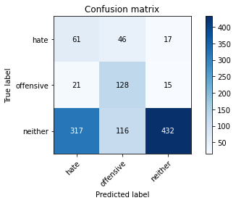

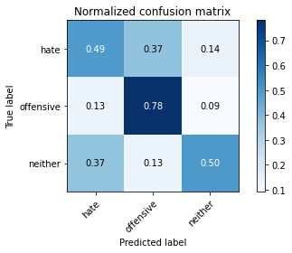

precision recall f1-score support

hate 0.15 0.49 0.23 124

offensive 0.44 0.78 0.56 164

neither 0.93 0.50 0.65 865

accuracy 0.54 1153

macro avg 0.51 0.59 0.48 1153

weighted avg 0.78 0.54 0.59 1153

average eval_loss: 1.9194414697844406, accuracy: 0.5385949696444059

training 8 epoch...

72.15794563293457 seconds used......

8 training finished! average train loss: 0.05526710892168228

evaluating...

Confusion matrix, without normalization

[[102 13 9]

[ 57 94 13]

[530 52 283]]

Normalized confusion matrix

[[0.82258065 0.10483871 0.07258065]

[0.34756098 0.57317073 0.07926829]

[0.61271676 0.06011561 0.32716763]]

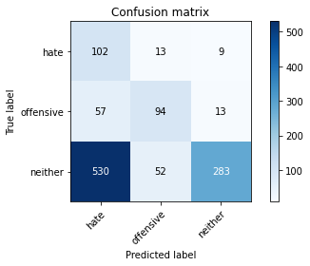

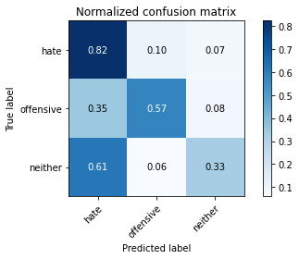

precision recall f1-score support

hate 0.15 0.82 0.25 124

offensive 0.59 0.57 0.58 164

neither 0.93 0.33 0.48 865

accuracy 0.42 1153

macro avg 0.56 0.57 0.44 1153

weighted avg 0.80 0.42 0.47 1153

average eval_loss: 2.9226315350368104, accuracy: 0.41543798785776237

training 9 epoch...

72.07876133918762 seconds used......

9 training finished! average train loss: 0.04918905363107721

evaluating...

Confusion matrix, without normalization

[[ 98 22 4]

[ 48 106 10]

[519 80 266]]

Normalized confusion matrix

[[0.79032258 0.17741935 0.03225806]

[0.29268293 0.64634146 0.06097561]

[0.6 0.09248555 0.30751445]]

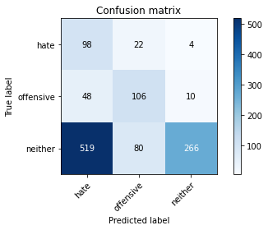

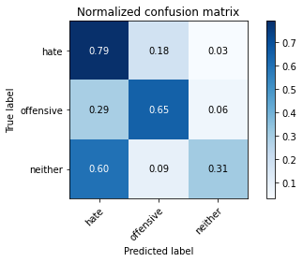

precision recall f1-score support

hate 0.15 0.79 0.25 124

offensive 0.51 0.65 0.57 164

neither 0.95 0.31 0.46 865

accuracy 0.41 1153

macro avg 0.54 0.58 0.43 1153

weighted avg 0.80 0.41 0.46 1153

average eval_loss: 3.212495281778533, accuracy: 0.40763226366001737

training 10 epoch...

72.08622860908508 seconds used......

10 training finished! average train loss: 0.034457769212340714

evaluating...

Confusion matrix, without normalization

[[ 92 18 14]

[ 38 116 10]

[432 76 357]]

Normalized confusion matrix

[[0.74193548 0.14516129 0.11290323]

[0.23170732 0.70731707 0.06097561]

[0.49942197 0.08786127 0.41271676]]

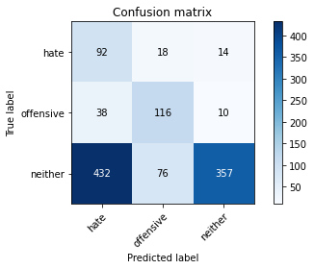

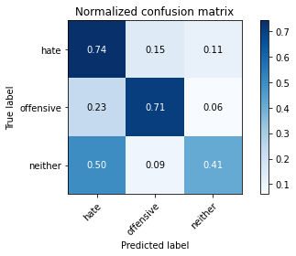

precision recall f1-score support

hate 0.16 0.74 0.27 124

offensive 0.55 0.71 0.62 164

neither 0.94 0.41 0.57 865

accuracy 0.49 1153

macro avg 0.55 0.62 0.49 1153

weighted avg 0.80 0.49 0.55 1153

average eval_loss: 2.7083357017615746, accuracy: 0.4900260190806591

3 run......

training 1 epoch...

72.08155989646912 seconds used......

1 training finished! average train loss: 0.9999093558816683

evaluating...

Confusion matrix, without normalization

[[100 19 5]

[ 55 107 2]

[752 75 38]]

Normalized confusion matrix

[[0.80645161 0.15322581 0.04032258]

[0.33536585 0.65243902 0.01219512]

[0.86936416 0.0867052 0.04393064]]

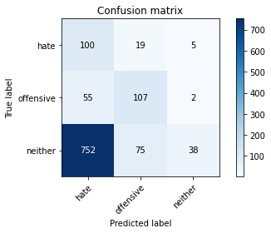

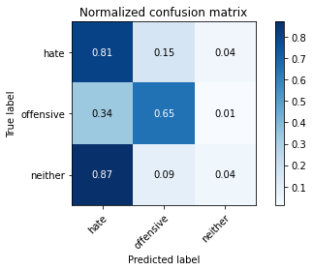

precision recall f1-score support

hate 0.11 0.81 0.19 124

offensive 0.53 0.65 0.59 164

neither 0.84 0.04 0.08 865

accuracy 0.21 1153

macro avg 0.50 0.50 0.29 1153

weighted avg 0.72 0.21 0.17 1153

average eval_loss: 1.027627091983269, accuracy: 0.212489158716392

training 2 epoch...

72.06430339813232 seconds used......

2 training finished! average train loss: 0.8485213010793641

evaluating...

Confusion matrix, without normalization

[[105 16 3]

[ 53 107 4]

[709 49 107]]

Normalized confusion matrix

[[0.84677419 0.12903226 0.02419355]

[0.32317073 0.65243902 0.02439024]

[0.81965318 0.0566474 0.12369942]]

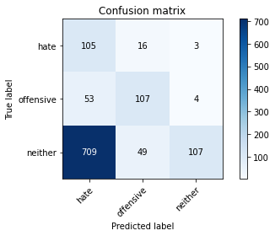

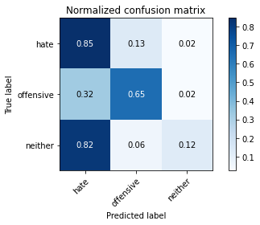

precision recall f1-score support

hate 0.12 0.85 0.21 124

offensive 0.62 0.65 0.64 164

neither 0.94 0.12 0.22 865

accuracy 0.28 1153

macro avg 0.56 0.54 0.36 1153

weighted avg 0.81 0.28 0.28 1153

average eval_loss: 1.1199130898919598, accuracy: 0.2766695576756288

training 3 epoch...

72.054856300354 seconds used......

3 training finished! average train loss: 0.6637681174491133

evaluating...

Confusion matrix, without normalization

[[ 99 16 9]

[ 50 102 12]

[483 46 336]]

Normalized confusion matrix

[[0.7983871 0.12903226 0.07258065]

[0.30487805 0.62195122 0.07317073]

[0.5583815 0.05317919 0.38843931]]

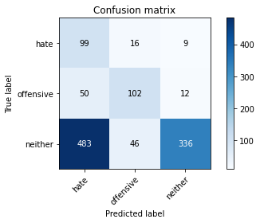

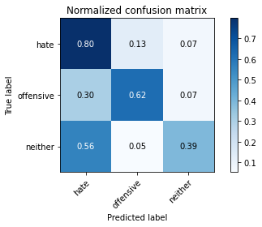

precision recall f1-score support

hate 0.16 0.80 0.26 124

offensive 0.62 0.62 0.62 164

neither 0.94 0.39 0.55 865

accuracy 0.47 1153

macro avg 0.57 0.60 0.48 1153

weighted avg 0.81 0.47 0.53 1153

average eval_loss: 1.0046580423568856, accuracy: 0.4657415437987858

training 4 epoch...

72.06995344161987 seconds used......

4 training finished! average train loss: 0.4073860602719443

evaluating...

Confusion matrix, without normalization

[[ 91 19 14]

[ 48 103 13]

[435 48 382]]

Normalized confusion matrix

[[0.73387097 0.15322581 0.11290323]

[0.29268293 0.62804878 0.07926829]

[0.50289017 0.05549133 0.4416185 ]]

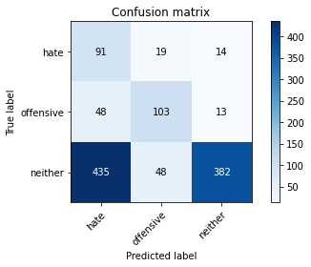

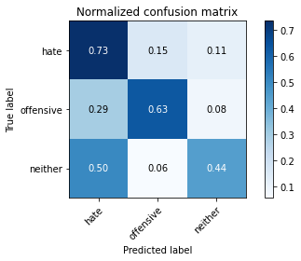

precision recall f1-score support

hate 0.16 0.73 0.26 124

offensive 0.61 0.63 0.62 164

neither 0.93 0.44 0.60 865

accuracy 0.50 1153

macro avg 0.57 0.60 0.49 1153

weighted avg 0.80 0.50 0.57 1153

average eval_loss: 1.2809218486835217, accuracy: 0.49956634865568084

training 5 epoch...

72.11118936538696 seconds used......

5 training finished! average train loss: 0.19434328938257836

evaluating...

Confusion matrix, without normalization

[[ 76 24 24]

[ 33 107 24]

[341 57 467]]

Normalized confusion matrix

[[0.61290323 0.19354839 0.19354839]

[0.20121951 0.65243902 0.14634146]

[0.39421965 0.06589595 0.53988439]]

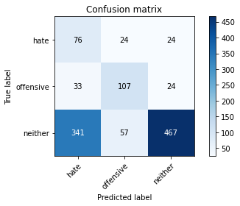

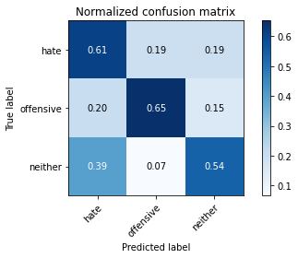

precision recall f1-score support

hate 0.17 0.61 0.26 124

offensive 0.57 0.65 0.61 164

neither 0.91 0.54 0.68 865

accuracy 0.56 1153

macro avg 0.55 0.60 0.52 1153

weighted avg 0.78 0.56 0.62 1153

average eval_loss: 1.3285150928743954, accuracy: 0.5637467476149176

training 6 epoch...

72.04049754142761 seconds used......

6 training finished! average train loss: 0.114164953962678

evaluating...

Confusion matrix, without normalization

[[ 89 15 20]

[ 41 101 22]

[365 48 452]]

Normalized confusion matrix

[[0.71774194 0.12096774 0.16129032]

[0.25 0.61585366 0.13414634]

[0.42196532 0.05549133 0.52254335]]

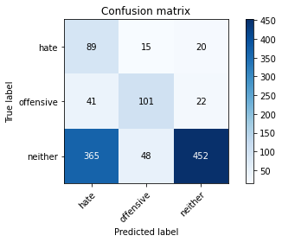

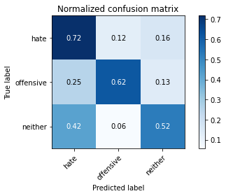

precision recall f1-score support

hate 0.18 0.72 0.29 124

offensive 0.62 0.62 0.62 164

neither 0.91 0.52 0.67 865

accuracy 0.56 1153

macro avg 0.57 0.62 0.52 1153

weighted avg 0.79 0.56 0.62 1153

average eval_loss: 1.725209151876384, accuracy: 0.5568083261058109

training 7 epoch...

72.09394693374634 seconds used......

7 training finished! average train loss: 0.07004315880337908

evaluating...

Confusion matrix, without normalization

[[ 92 24 8]

[ 38 115 11]

[484 76 305]]

Normalized confusion matrix

[[0.74193548 0.19354839 0.06451613]

[0.23170732 0.70121951 0.06707317]

[0.55953757 0.08786127 0.35260116]]

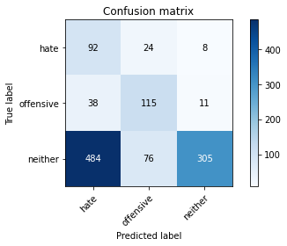

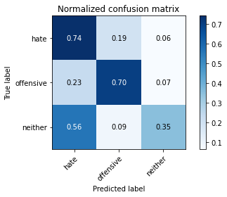

precision recall f1-score support

hate 0.15 0.74 0.25 124

offensive 0.53 0.70 0.61 164

neither 0.94 0.35 0.51 865

accuracy 0.44 1153

macro avg 0.54 0.60 0.46 1153

weighted avg 0.80 0.44 0.50 1153

average eval_loss: 2.6511526457194625, accuracy: 0.4440589765828274

training 8 epoch...

72.20901393890381 seconds used......

8 training finished! average train loss: 0.052210970182343205

evaluating...

Confusion matrix, without normalization

[[ 79 18 27]

[ 33 106 25]

[305 50 510]]

Normalized confusion matrix

[[0.63709677 0.14516129 0.21774194]

[0.20121951 0.64634146 0.15243902]

[0.35260116 0.05780347 0.58959538]]

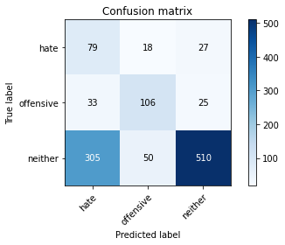

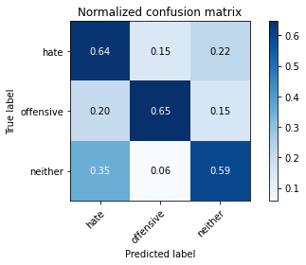

precision recall f1-score support

hate 0.19 0.64 0.29 124

offensive 0.61 0.65 0.63 164

neither 0.91 0.59 0.71 865

accuracy 0.60 1153

macro avg 0.57 0.62 0.54 1153

weighted avg 0.79 0.60 0.66 1153

average eval_loss: 1.6593065364607449, accuracy: 0.6027753686036427

training 9 epoch...

72.1796178817749 seconds used......

9 training finished! average train loss: 0.04645883245601518

evaluating...

Confusion matrix, without normalization

[[ 85 27 12]

[ 28 117 19]

[377 75 413]]

Normalized confusion matrix

[[0.68548387 0.21774194 0.09677419]

[0.17073171 0.71341463 0.11585366]

[0.43583815 0.0867052 0.47745665]]

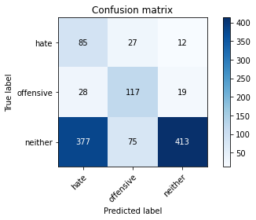

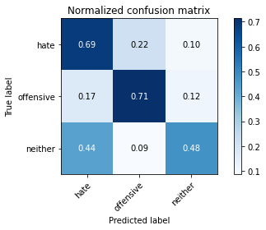

precision recall f1-score support

hate 0.17 0.69 0.28 124

offensive 0.53 0.71 0.61 164

neither 0.93 0.48 0.63 865

accuracy 0.53 1153

macro avg 0.55 0.63 0.51 1153

weighted avg 0.79 0.53 0.59 1153

average eval_loss: 2.3200420223433396, accuracy: 0.5333911535125759

training 10 epoch...

72.15746665000916 seconds used......

10 training finished! average train loss: 0.04165275862933846

evaluating...

Confusion matrix, without normalization

[[ 91 18 15]

[ 42 104 18]

[431 47 387]]

Normalized confusion matrix

[[0.73387097 0.14516129 0.12096774]

[0.25609756 0.63414634 0.1097561 ]

[0.4982659 0.05433526 0.44739884]]

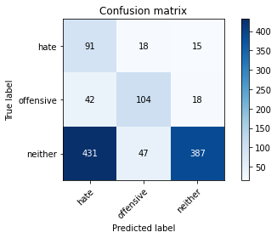

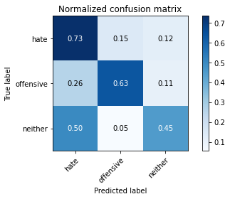

precision recall f1-score support

hate 0.16 0.73 0.26 124

offensive 0.62 0.63 0.62 164

neither 0.92 0.45 0.60 865

accuracy 0.50 1153

macro avg 0.57 0.61 0.50 1153

weighted avg 0.80 0.50 0.57 1153

average eval_loss: 2.3450905043503334, accuracy: 0.5047701647875108

4 run......

training 1 epoch...

72.28481602668762 seconds used......

1 training finished! average train loss: 1.010128813130515

evaluating...

Confusion matrix, without normalization

[[110 14 0]

[ 77 86 1]

[783 68 14]]

Normalized confusion matrix

[[0.88709677 0.11290323 0. ]

[0.4695122 0.52439024 0.00609756]

[0.90520231 0.07861272 0.01618497]]

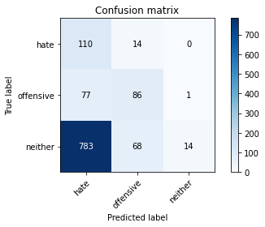

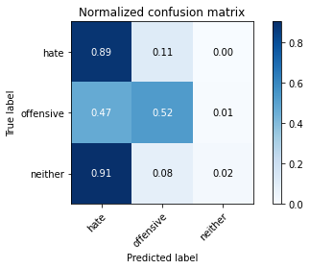

precision recall f1-score support

hate 0.11 0.89 0.20 124

offensive 0.51 0.52 0.52 164

neither 0.93 0.02 0.03 865

accuracy 0.18 1153

macro avg 0.52 0.48 0.25 1153

weighted avg 0.79 0.18 0.12 1153

average eval_loss: 1.0966623076077164, accuracy: 0.1821335646140503

training 2 epoch...

72.08963704109192 seconds used......

2 training finished! average train loss: 0.8601650783703441

evaluating...

Confusion matrix, without normalization

[[ 95 21 8]

[ 39 119 6]

[472 79 314]]

Normalized confusion matrix

[[0.76612903 0.16935484 0.06451613]

[0.23780488 0.72560976 0.03658537]

[0.54566474 0.09132948 0.36300578]]

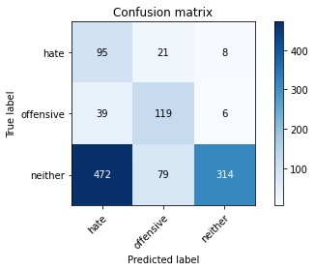

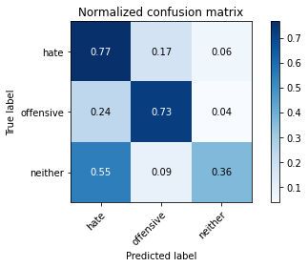

precision recall f1-score support

hate 0.16 0.77 0.26 124

offensive 0.54 0.73 0.62 164

neither 0.96 0.36 0.53 865

accuracy 0.46 1153

macro avg 0.55 0.62 0.47 1153

weighted avg 0.81 0.46 0.51 1153

average eval_loss: 0.9110568474079, accuracy: 0.45793581960104074

training 3 epoch...

72.23689198493958 seconds used......

3 training finished! average train loss: 0.7201475295282546

evaluating...

Confusion matrix, without normalization

[[ 75 25 24]

[ 40 113 11]

[304 77 484]]

Normalized confusion matrix

[[0.60483871 0.2016129 0.19354839]

[0.24390244 0.68902439 0.06707317]

[0.35144509 0.08901734 0.55953757]]

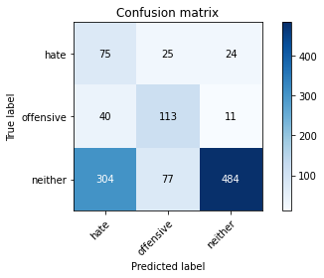

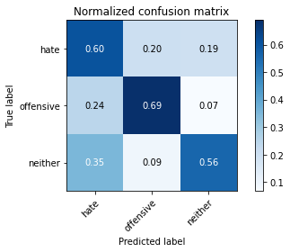

precision recall f1-score support

hate 0.18 0.60 0.28 124

offensive 0.53 0.69 0.60 164

neither 0.93 0.56 0.70 865

accuracy 0.58 1153

macro avg 0.55 0.62 0.52 1153

weighted avg 0.79 0.58 0.64 1153

average eval_loss: 0.8517951348732258, accuracy: 0.5828274067649609

training 4 epoch...

72.17429900169373 seconds used......

4 training finished! average train loss: 0.48779461523961454

evaluating...

Confusion matrix, without normalization

[[ 80 40 4]

[ 31 127 6]

[498 144 223]]

Normalized confusion matrix

[[0.64516129 0.32258065 0.03225806]

[0.18902439 0.77439024 0.03658537]

[0.57572254 0.16647399 0.25780347]]

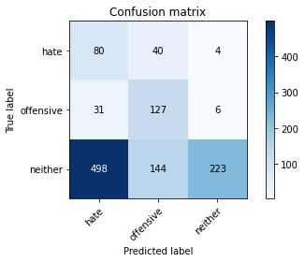

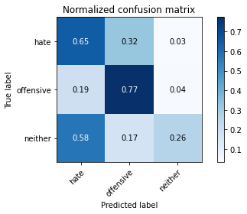

precision recall f1-score support

hate 0.13 0.65 0.22 124

offensive 0.41 0.77 0.53 164

neither 0.96 0.26 0.41 865

accuracy 0.37 1153

macro avg 0.50 0.56 0.39 1153

weighted avg 0.79 0.37 0.40 1153

average eval_loss: 1.4851918857673119, accuracy: 0.37294015611448394

training 5 epoch...

72.0892927646637 seconds used......

5 training finished! average train loss: 0.24117534379253075

evaluating...

Confusion matrix, without normalization

[[ 93 20 11]

[ 42 111 11]

[446 78 341]]

Normalized confusion matrix

[[0.75 0.16129032 0.08870968]

[0.25609756 0.67682927 0.06707317]

[0.51560694 0.09017341 0.39421965]]

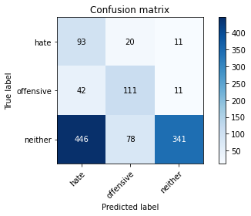

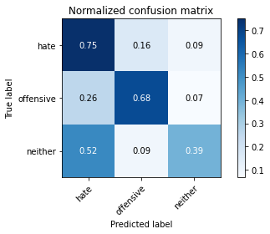

precision recall f1-score support

hate 0.16 0.75 0.26 124

offensive 0.53 0.68 0.60 164

neither 0.94 0.39 0.56 865

accuracy 0.47 1153

macro avg 0.54 0.61 0.47 1153

weighted avg 0.80 0.47 0.53 1153

average eval_loss: 1.6185172282416245, accuracy: 0.47267996530789247

training 6 epoch...

72.03976464271545 seconds used......

6 training finished! average train loss: 0.13323992267916246

evaluating...

Confusion matrix, without normalization

[[ 84 16 24]

[ 39 105 20]

[368 67 430]]

Normalized confusion matrix

[[0.67741935 0.12903226 0.19354839]

[0.23780488 0.6402439 0.12195122]

[0.42543353 0.07745665 0.49710983]]

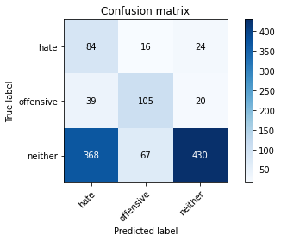

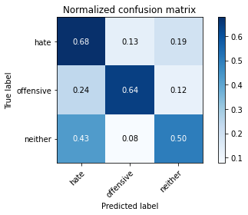

precision recall f1-score support

hate 0.17 0.68 0.27 124

offensive 0.56 0.64 0.60 164

neither 0.91 0.50 0.64 865

accuracy 0.54 1153

macro avg 0.55 0.60 0.50 1153

weighted avg 0.78 0.54 0.60 1153

average eval_loss: 1.527764482744809, accuracy: 0.5368603642671292

training 7 epoch...

72.07416081428528 seconds used......

7 training finished! average train loss: 0.07460638092985998

evaluating...

Confusion matrix, without normalization

[[ 80 26 18]

[ 32 117 15]

[396 91 378]]

Normalized confusion matrix

[[0.64516129 0.20967742 0.14516129]

[0.19512195 0.71341463 0.09146341]

[0.45780347 0.10520231 0.43699422]]

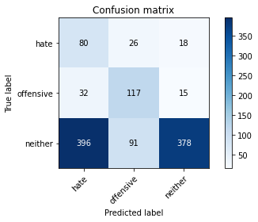

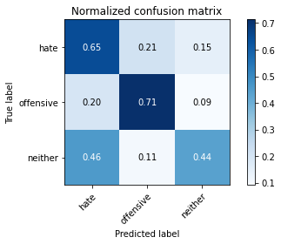

precision recall f1-score support

hate 0.16 0.65 0.25 124

offensive 0.50 0.71 0.59 164

neither 0.92 0.44 0.59 865

accuracy 0.50 1153

macro avg 0.53 0.60 0.48 1153

weighted avg 0.78 0.50 0.56 1153

average eval_loss: 1.9450265333570282, accuracy: 0.4986990459670425

training 8 epoch...

72.12267017364502 seconds used......

8 training finished! average train loss: 0.05632593565609395

evaluating...

Confusion matrix, without normalization

[[ 82 27 15]

[ 34 117 13]

[388 101 376]]

Normalized confusion matrix

[[0.66129032 0.21774194 0.12096774]

[0.20731707 0.71341463 0.07926829]

[0.44855491 0.11676301 0.43468208]]

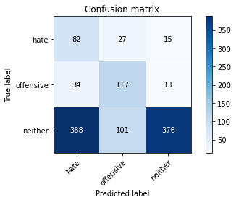

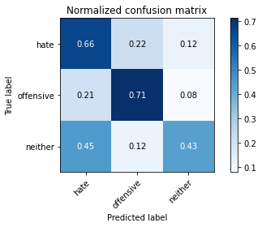

precision recall f1-score support

hate 0.16 0.66 0.26 124

offensive 0.48 0.71 0.57 164

neither 0.93 0.43 0.59 865

accuracy 0.50 1153

macro avg 0.52 0.60 0.48 1153

weighted avg 0.78 0.50 0.55 1153

average eval_loss: 2.20202414331765, accuracy: 0.4986990459670425

training 9 epoch...

71.96469116210938 seconds used......

9 training finished! average train loss: 0.03676469529870831

evaluating...

Confusion matrix, without normalization

[[ 73 26 25]

[ 30 116 18]

[304 91 470]]

Normalized confusion matrix

[[0.58870968 0.20967742 0.2016129 ]

[0.18292683 0.70731707 0.1097561 ]

[0.35144509 0.10520231 0.5433526 ]]

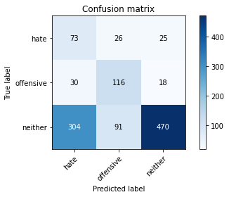

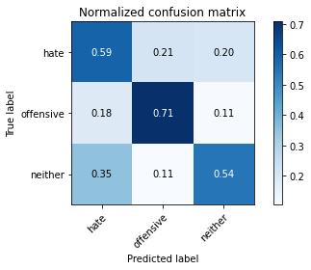

precision recall f1-score support

hate 0.18 0.59 0.27 124

offensive 0.50 0.71 0.58 164

neither 0.92 0.54 0.68 865

accuracy 0.57 1153

macro avg 0.53 0.61 0.51 1153

weighted avg 0.78 0.57 0.62 1153

average eval_loss: 1.8409260593611618, accuracy: 0.5715524718126627

training 10 epoch...

72.0870008468628 seconds used......

10 training finished! average train loss: 0.04028110032266427

evaluating...

Confusion matrix, without normalization

[[ 80 31 13]

[ 33 122 9]

[440 127 298]]

Normalized confusion matrix

[[0.64516129 0.25 0.10483871]

[0.20121951 0.74390244 0.05487805]

[0.50867052 0.14682081 0.34450867]]

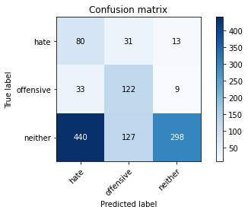

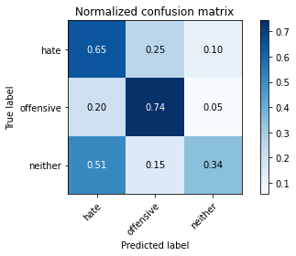

precision recall f1-score support

hate 0.14 0.65 0.24 124

offensive 0.44 0.74 0.55 164

neither 0.93 0.34 0.50 865

accuracy 0.43 1153

macro avg 0.50 0.58 0.43 1153

weighted avg 0.78 0.43 0.48 1153

average eval_loss: 2.630406959303494, accuracy: 0.4336513443191674

5 run......

training 1 epoch...

72.09433007240295 seconds used......

1 training finished! average train loss: 1.001135236450604

evaluating...

Confusion matrix, without normalization

[[ 84 38 2]

[ 39 121 4]

[664 128 73]]

Normalized confusion matrix

[[0.67741935 0.30645161 0.01612903]

[0.23780488 0.73780488 0.02439024]

[0.76763006 0.14797688 0.08439306]]

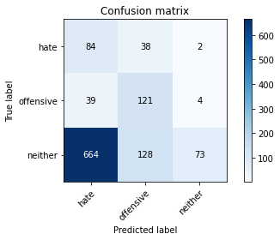

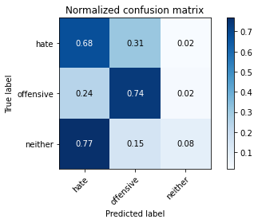

precision recall f1-score support

hate 0.11 0.68 0.18 124

offensive 0.42 0.74 0.54 164

neither 0.92 0.08 0.15 865

accuracy 0.24 1153

macro avg 0.48 0.50 0.29 1153

weighted avg 0.76 0.24 0.21 1153

average eval_loss: 1.0635648195085854, accuracy: 0.24111014744145706

training 2 epoch...

72.04546594619751 seconds used......

2 training finished! average train loss: 0.8613579276771772

evaluating...

Confusion matrix, without normalization

[[ 91 26 7]

[ 38 119 7]

[449 77 339]]

Normalized confusion matrix

[[0.73387097 0.20967742 0.05645161]

[0.23170732 0.72560976 0.04268293]

[0.51907514 0.08901734 0.39190751]]

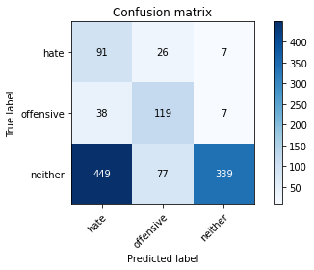

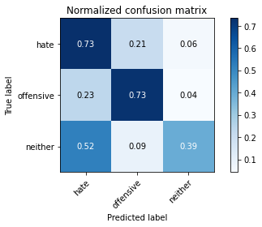

precision recall f1-score support

hate 0.16 0.73 0.26 124

offensive 0.54 0.73 0.62 164

neither 0.96 0.39 0.56 865

accuracy 0.48 1153

macro avg 0.55 0.62 0.48 1153

weighted avg 0.81 0.48 0.53 1153

average eval_loss: 0.9193352070348016, accuracy: 0.4761491760624458

training 3 epoch...

71.9698588848114 seconds used......

3 training finished! average train loss: 0.7149422709785757

evaluating...

Confusion matrix, without normalization

[[ 80 31 13]

[ 32 117 15]

[345 85 435]]

Normalized confusion matrix

[[0.64516129 0.25 0.10483871]

[0.19512195 0.71341463 0.09146341]

[0.39884393 0.0982659 0.50289017]]

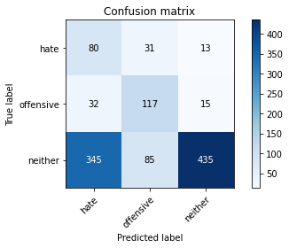

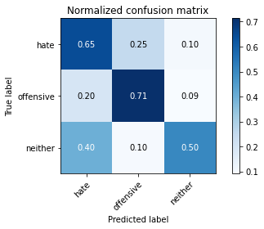

precision recall f1-score support

hate 0.18 0.65 0.28 124

offensive 0.50 0.71 0.59 164

neither 0.94 0.50 0.66 865

accuracy 0.55 1153

macro avg 0.54 0.62 0.51 1153

weighted avg 0.80 0.55 0.60 1153

average eval_loss: 0.8947857248372045, accuracy: 0.5481352992194276

training 4 epoch...

72.0274908542633 seconds used......

4 training finished! average train loss: 0.47367217595733346

evaluating...

Confusion matrix, without normalization

[[ 77 24 23]

[ 28 119 17]

[322 80 463]]

Normalized confusion matrix

[[0.62096774 0.19354839 0.18548387]

[0.17073171 0.72560976 0.10365854]

[0.37225434 0.09248555 0.53526012]]

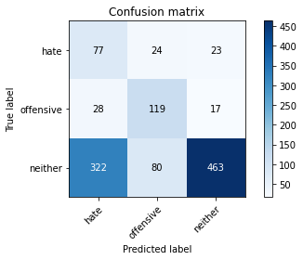

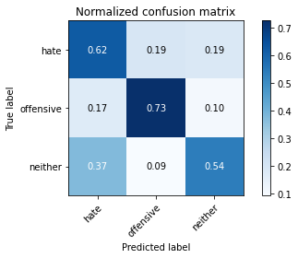

precision recall f1-score support

hate 0.18 0.62 0.28 124

offensive 0.53 0.73 0.61 164

neither 0.92 0.54 0.68 865

accuracy 0.57 1153

macro avg 0.54 0.63 0.52 1153

weighted avg 0.79 0.57 0.63 1153

average eval_loss: 1.0599649815723813, accuracy: 0.5715524718126627

training 5 epoch...

72.02513432502747 seconds used......

5 training finished! average train loss: 0.23868458589450234

evaluating...

Confusion matrix, without normalization

[[ 99 18 7]

[ 45 110 9]

[455 68 342]]

Normalized confusion matrix

[[0.7983871 0.14516129 0.05645161]

[0.27439024 0.67073171 0.05487805]

[0.52601156 0.07861272 0.39537572]]

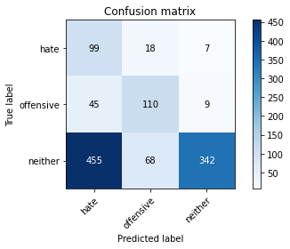

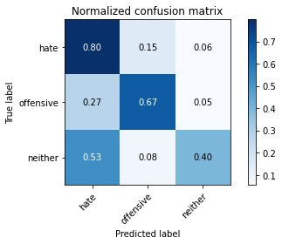

precision recall f1-score support

hate 0.17 0.80 0.27 124

offensive 0.56 0.67 0.61 164

neither 0.96 0.40 0.56 865

accuracy 0.48 1153

macro avg 0.56 0.62 0.48 1153

weighted avg 0.81 0.48 0.54 1153

average eval_loss: 1.9208679476688648, accuracy: 0.4778837814397225

training 6 epoch...

72.01950407028198 seconds used......

6 training finished! average train loss: 0.1277117965510115

evaluating...

Confusion matrix, without normalization

[[ 91 27 6]

[ 43 114 7]

[474 81 310]]

Normalized confusion matrix

[[0.73387097 0.21774194 0.0483871 ]

[0.26219512 0.69512195 0.04268293]

[0.54797688 0.09364162 0.3583815 ]]

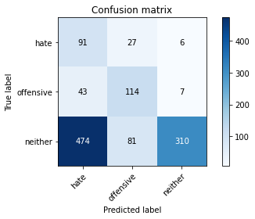

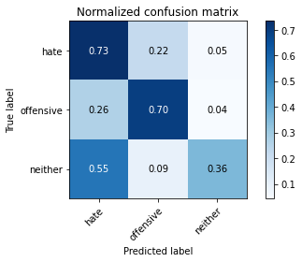

precision recall f1-score support

hate 0.15 0.73 0.25 124

offensive 0.51 0.70 0.59 164

neither 0.96 0.36 0.52 865

accuracy 0.45 1153

macro avg 0.54 0.60 0.45 1153

weighted avg 0.81 0.45 0.50 1153

average eval_loss: 2.494321481934909, accuracy: 0.44666088464874243

training 7 epoch...

72.05238676071167 seconds used......

7 training finished! average train loss: 0.08663926316269983

evaluating...

Confusion matrix, without normalization

[[ 95 15 14]

[ 58 93 13]

[451 50 364]]

Normalized confusion matrix

[[0.76612903 0.12096774 0.11290323]

[0.35365854 0.56707317 0.07926829]

[0.52138728 0.05780347 0.42080925]]

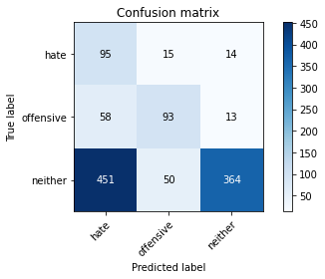

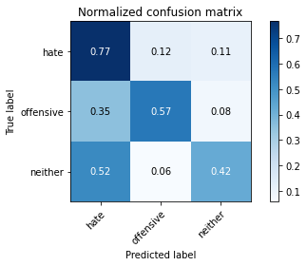

precision recall f1-score support

hate 0.16 0.77 0.26 124

offensive 0.59 0.57 0.58 164

neither 0.93 0.42 0.58 865

accuracy 0.48 1153

macro avg 0.56 0.58 0.47 1153

weighted avg 0.80 0.48 0.55 1153

average eval_loss: 2.192078418772796, accuracy: 0.4787510841283608

training 8 epoch...

72.14991641044617 seconds used......

8 training finished! average train loss: 0.05430494132728893

evaluating...

Confusion matrix, without normalization

[[ 89 19 16]

[ 44 104 16]

[375 50 440]]

Normalized confusion matrix

[[0.71774194 0.15322581 0.12903226]

[0.26829268 0.63414634 0.09756098]

[0.43352601 0.05780347 0.50867052]]

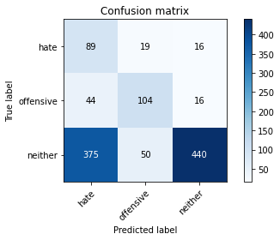

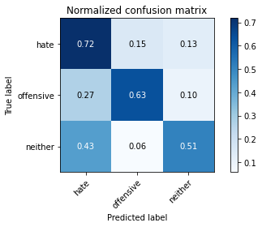

precision recall f1-score support

hate 0.18 0.72 0.28 124

offensive 0.60 0.63 0.62 164

neither 0.93 0.51 0.66 865

accuracy 0.55 1153

macro avg 0.57 0.62 0.52 1153

weighted avg 0.80 0.55 0.61 1153

average eval_loss: 1.9470520029807914, accuracy: 0.5490026019080659

training 9 epoch...

72.16505289077759 seconds used......

9 training finished! average train loss: 0.057469566004112405

evaluating...

Confusion matrix, without normalization

[[101 17 6]

[ 44 105 15]

[485 48 332]]

Normalized confusion matrix

[[0.81451613 0.13709677 0.0483871 ]

[0.26829268 0.6402439 0.09146341]

[0.56069364 0.05549133 0.38381503]]

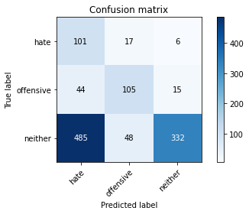

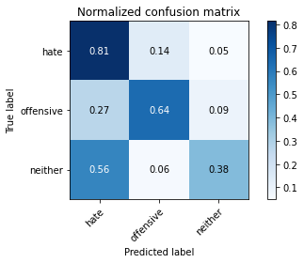

precision recall f1-score support

hate 0.16 0.81 0.27 124

offensive 0.62 0.64 0.63 164

neither 0.94 0.38 0.55 865

accuracy 0.47 1153

macro avg 0.57 0.61 0.48 1153

weighted avg 0.81 0.47 0.53 1153

average eval_loss: 2.480159551932894, accuracy: 0.4666088464874241

training 10 epoch...

72.07881045341492 seconds used......

10 training finished! average train loss: 0.03855639894928096

evaluating...

Confusion matrix, without normalization

[[ 86 29 9]

[ 39 116 9]

[441 98 326]]

Normalized confusion matrix

[[0.69354839 0.23387097 0.07258065]

[0.23780488 0.70731707 0.05487805]

[0.50982659 0.1132948 0.37687861]]

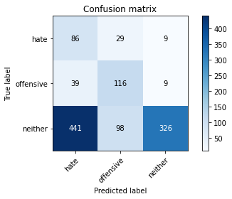

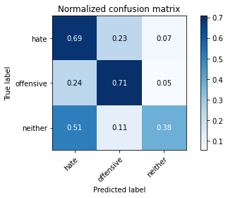

precision recall f1-score support

hate 0.15 0.69 0.25 124

offensive 0.48 0.71 0.57 164

neither 0.95 0.38 0.54 865

accuracy 0.46 1153

macro avg 0.53 0.59 0.45 1153

weighted avg 0.80 0.46 0.51 1153

average eval_loss: 2.781191573060792, accuracy: 0.45793581960104074